Problem Statement: Launch an EC2 instance (Windows) along with a web server. Then, create an EBS volume of 5 GB, attach it to an EC2 machine (Windows), and take a snapshot. Finally, create an EBS volume using the taken snapshot.

Part 1: Launch an EC2 instance (Windows) along with a web server:

Launching an windows EC2 instance:

AWS EC2 🡪 Select Windows and launch an windows instance

Connect it with RDP client remotely.

Configuring web server:

Launch Server manager

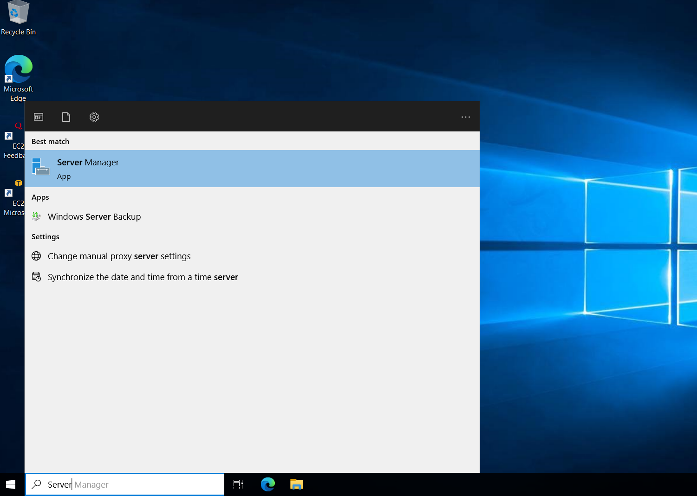

Click on the “Add Roles and Features”

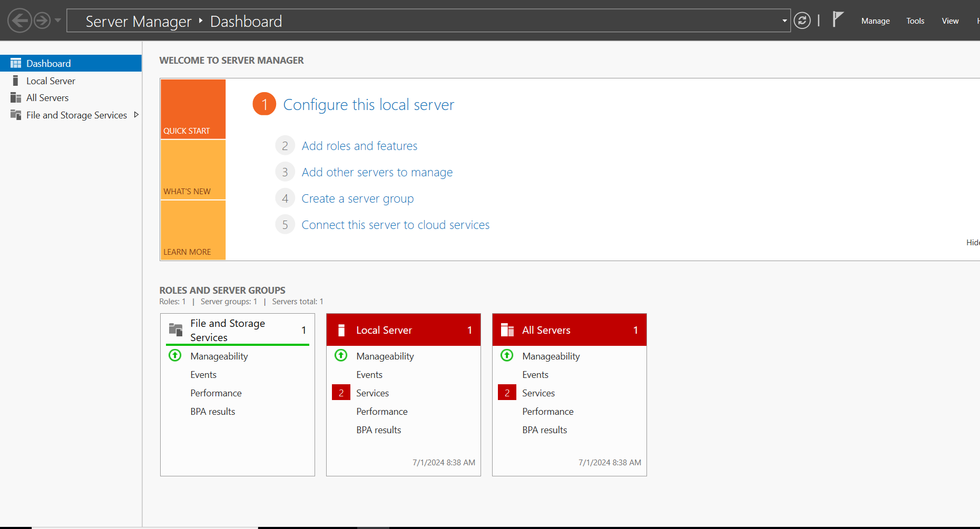

Select Role-based or feature based installation

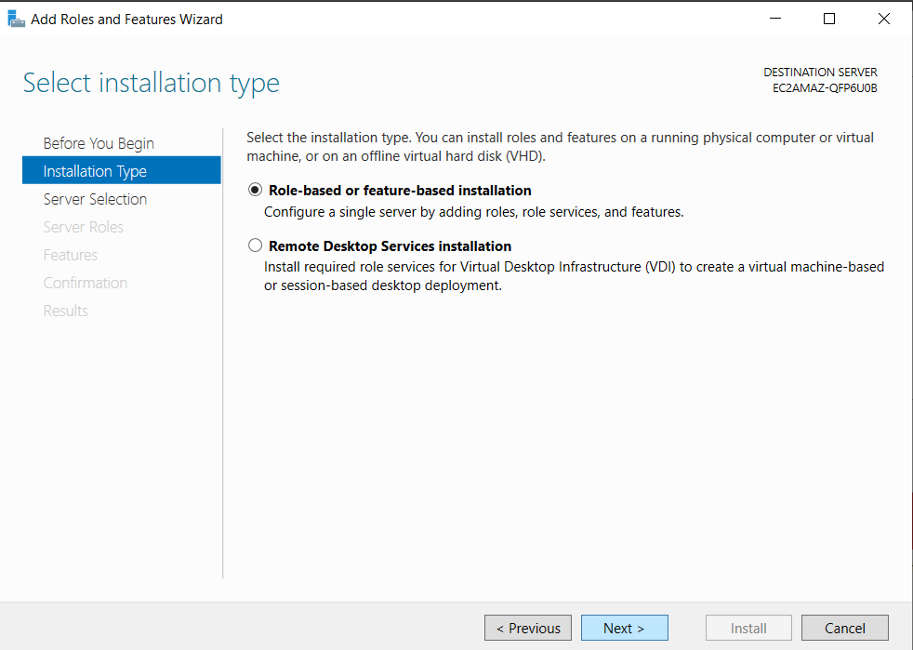

Select “Web Server(IIS)” and click Next for all the configurations

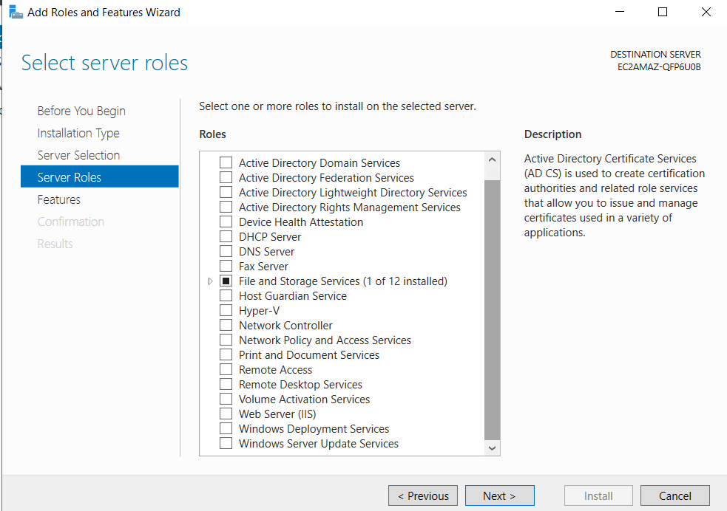

Click on “Install” and installation will get finished

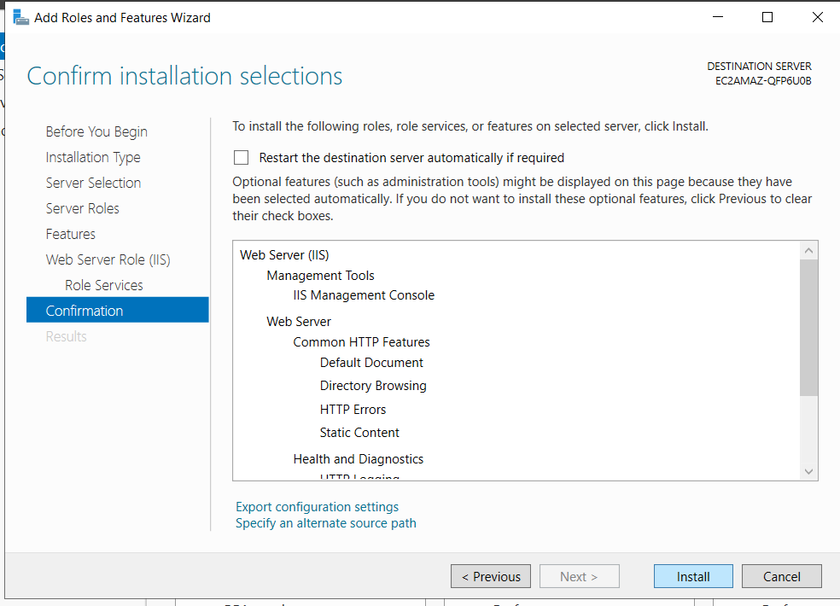

Click on Close once installation is finished,

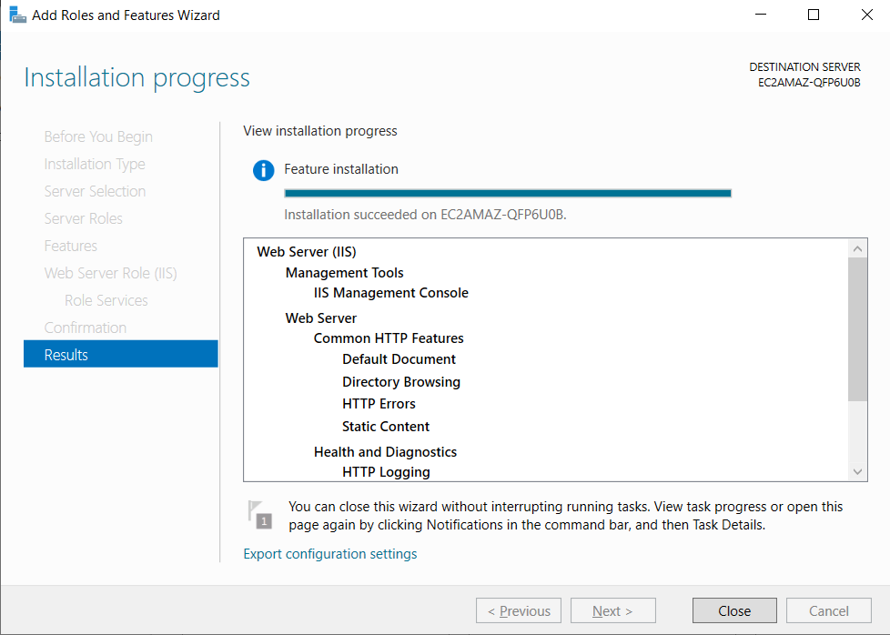

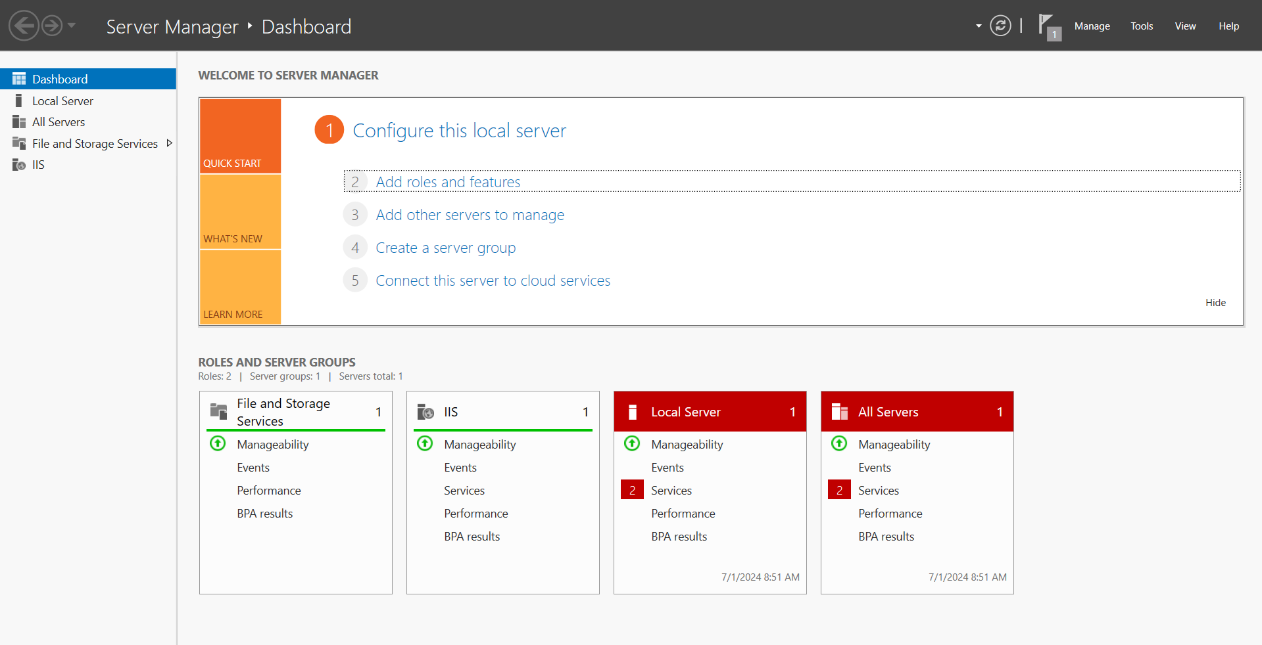

Now check if the server is running by running the local host application without any port numbers,

Eg., <https://54.165.115.255/>

We will be getting the web server loaded by default.

Part 2: Create an EBS volume of 5 GB, attach it to an EC2 machine (Windows), and take a snapshot.

Click on “Create Volume”

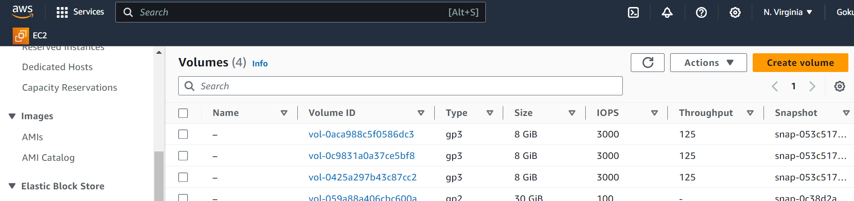

Select and fill the required configuration like Size, Availability Zone and more, and click on Create Volume

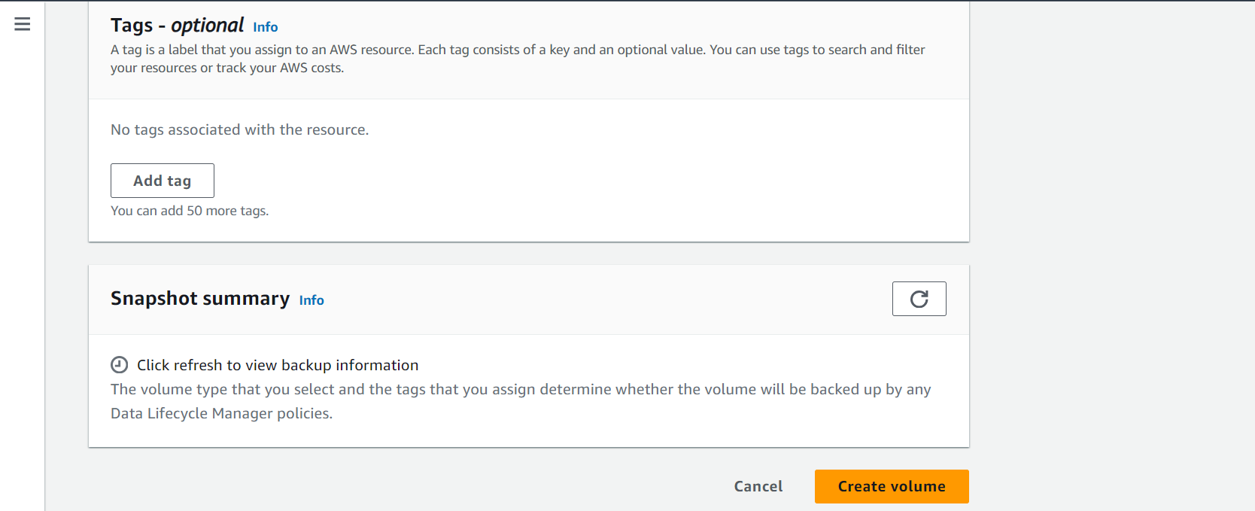

Now click on the list view page and select the created volume and select the “Attach Volume” option,

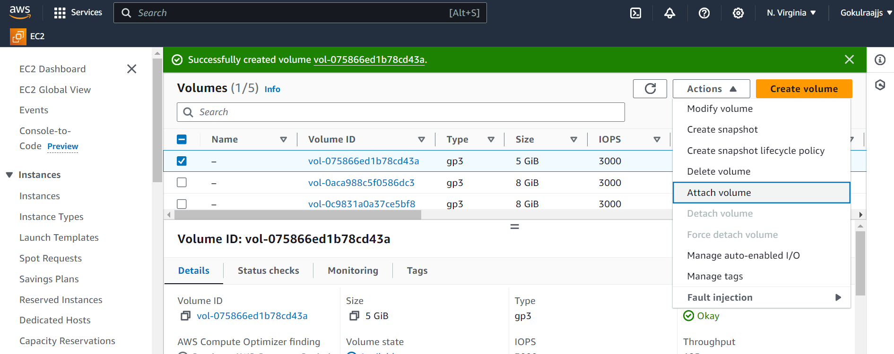

Now choose the available instances and select the name in the field and click on “Attach volume”

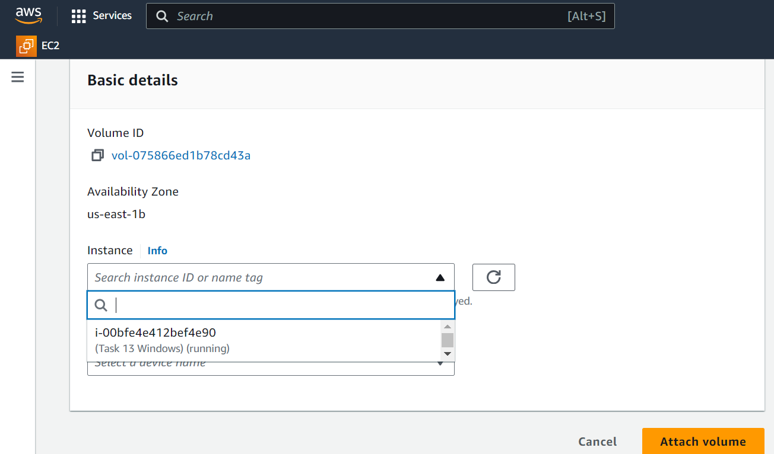

Now go to the Snapshots page and click on “Create Snapshot”

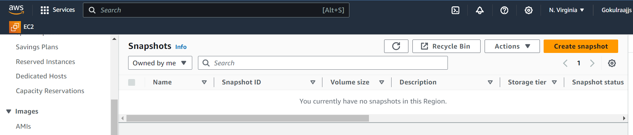

Select the available volume from the list and click “Create Snapshot”

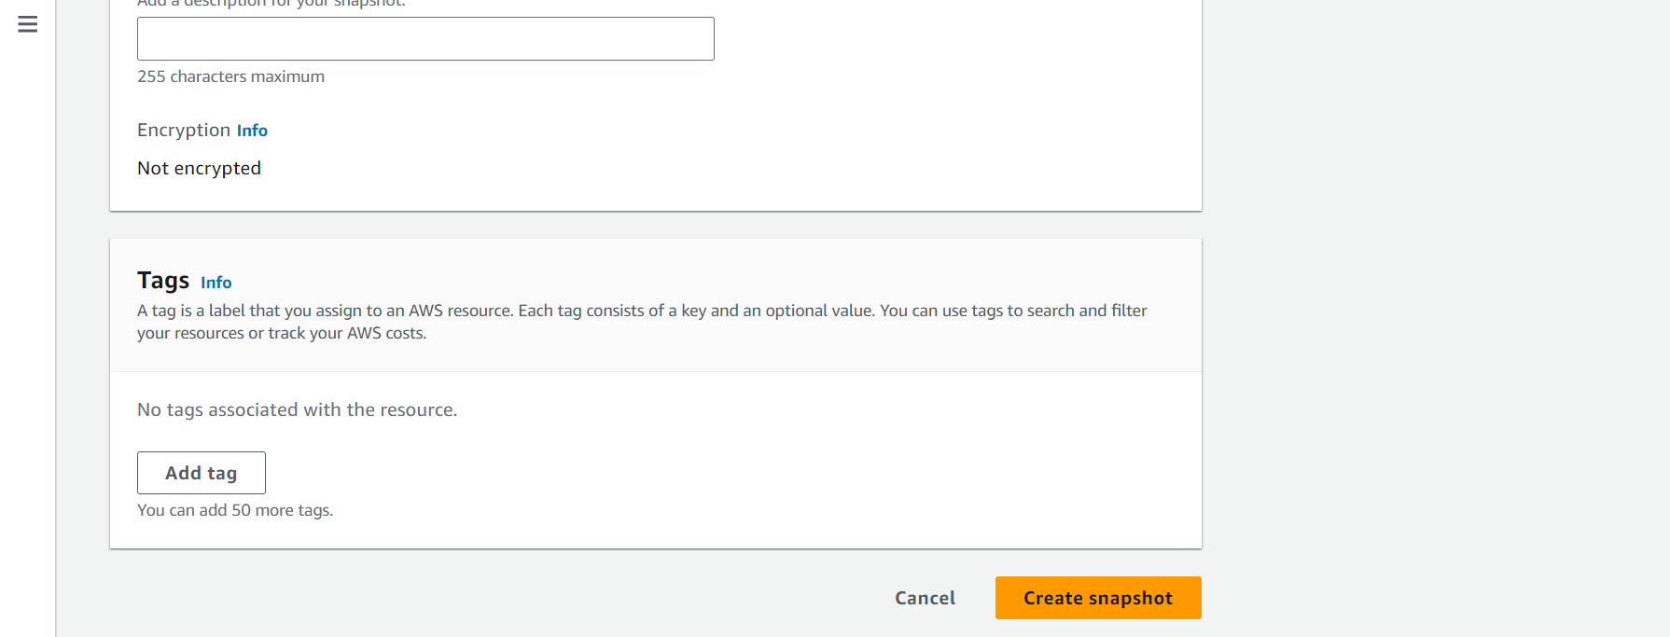

Part 3: Finally, create an EBS volume using the taken snapshot.

Click on the selected Snapshot and go to the actions and select “Create Volume from Snapshot”

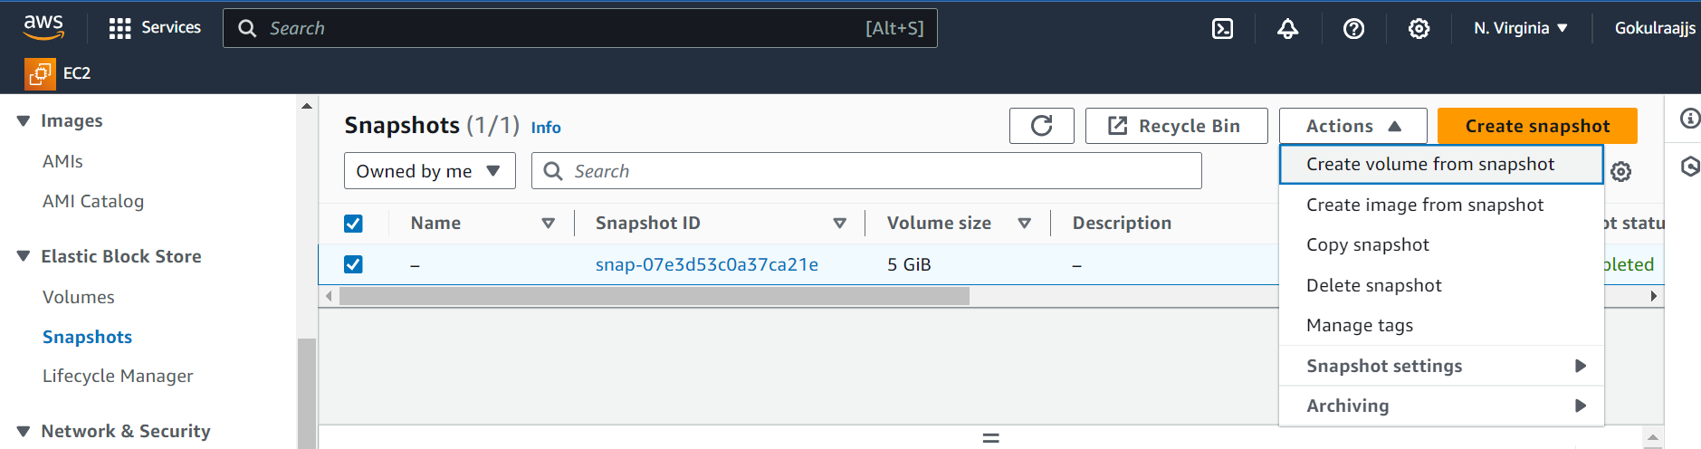

Fill all the checkbox and click “Create Volume”

